INTM558210: Hybrids: Dual Territory Double Deduction (Chapter 10): Examples: Multinational company double deduction

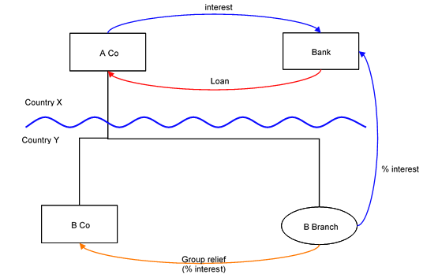

Background
- A Co is resident in Country X, and has a permanent establishment in Country Y (‘B Branch’).

- Both Country X and Y treat B Branch as giving rise to a permanent establishment in Country Y.

- A Co borrows money from an unrelated third party (Bank) and uses the loan to fund income-earning assets in Country Y.

- Country X allows A Co a deduction for the full amount of this interest expense.

- Country Y allows B Branch a deduction for a portion of the interest expense (‘%interest’) on the same loan.

- B Branch does not have any income and surrenders the loss arising from the interest deduction to B Co (a group company resident in Country Y) under a group relief provision of Country Y.

Analysis - Applying the tests in s259JA TIOPA 2010
Do the interest payment by A Co and the interest deduction allowed to B Branch satisfy the relevant conditions to fall within the scope of the dual territory double deduction rules?

Condition A: Is there a relevant multinational or dual resident company?
The definition of relevant multinational company is given at s259JA(4).
S259JA(4)(a) is satisfied as A Co is within the charge to tax in a country in which it is not resident because it carries on business in Country Y (‘the PE jurisdiction’) through a permanent establishment (B Branch).
If the UK is either Country X (the parent jurisdiction) or Country Y (the PE jurisdiction), the requirements at s259JA(4)(b) are met and A Co is a relevant multinational company.
Condition A is satisfied.
If the UK is neither Country X nor Country Y then the condition is not satisfied. If this is the case then the imported mismatch rules within s259K TIOPA 2010 should be considered.

Condition B: Is it reasonable to suppose that there is a dual territory double deduction amount that arises because the company is a multinational or dual resident company?
Given the facts above, it is reasonable to suppose that Country X will permit A Co a full deduction for the interest expense under the loan in the payment period.
It is also reasonable to suppose that Country Y will also permit a proportion of the interest expense (% interest) to be deducted in calculating the taxable income of Branch B, which is merely a part of A Co.
This double deduction arises because A Co is a relevant multinational company.
Condition B is satisfied.
The extent of the dual territory double deduction amount is %interest, being the amount of the interest deduction allowed to Branch B in Country Y.

Conclusion
As both conditions are satisfied, the relevant counteraction must be considered in respect of amounts identified as dual territory double deductions.

Counteraction
The counteraction applicable will depend upon whether the UK is in the position of Country X or Country Y.

Counteraction where the UK is in the position of Country X (parent jurisdiction)
Where the UK is in the position of Country X (the parent jurisdiction) then s259JC will apply.
There is no dual inclusion income arising in relation to A Co/B Branch. The deduction in B Branch creates a loss which is surrendered as group relief to B Co. The dual territory double deduction amount is in substance deducted from the income of B Co. Consequently, the amount surrendered is an impermissible overseas deduction.
The interest deduction available to A Co is reduced by this impermissible overseas deduction.
If B Branch did not surrender its loss, there would be no impermissible overseas deduction and there would be no need to restrict the deduction available to A Co.

Counteraction where the UK is in the position of Country Y (the PE jurisdiction)
Where the UK is in the position of Country Y (the PE jurisdiction), and it is reasonable to suppose that the dual territory double deduction amount has not been fully counteracted by any other country under a counteraction equivalent to s259JC, then s259JD will apply.
The UK will deny B Branch a deduction for the dual territory double deduction amount to the extent that it is not set against dual inclusion income. In this example, as B Branch has no income there can be no dual inclusion income and so the full dual territory double deduction (% interest) will be denied. As the UK has denied the deduction, B Branch no longer has a loss to surrender under group relief provisions. If there had been dual inclusion income, the dual territory double deduction could be allowed as a deduction in B Branch to the extent that;
- it did not exceed the dual inclusion income
- the measure of dual inclusion income was restricted by the amount of any illegitimate overseas deduction in Country X.
Any dual territory double deduction amount that cannot be deducted from B Branch’s dual inclusion income for the deduction period is carried forward and deducted from dual inclusion income of subsequent accounting periods.
If the Commissioners are satisfied that –
- the company has ceased to be a relevant multinational company, and
- B Branch has not been able to deduct the dual territory double deduction from dual inclusion income of subsequent periods,
then those stranded deductions may be deducted from B Branch’s taxable total profits in its final accounting period (i.e. the period in which the company ceased to be a relevant multinational company).
Return to contents

