INTM551370: Hybrids: Financial instruments (Chapter 3): Example: Interest component of the purchase price of shares
This example looks at situations where a company transfers shares to a related company in exchange for payment. This payment is deferred and interest is applied to the unpaid amount.
The example considers whether the interest element of the payment falls within the hybrid and other mismatches from financial instruments rules, and how it should be treated.

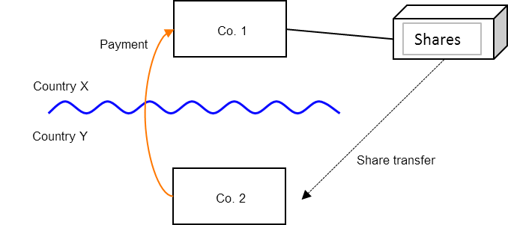

Background
- Co. 1 is a company resident in Country X.
- Co. 2 is a related company, resident in Country Y.
- Co. 1 transfers shares to Co. 2, which pays the market value for the shares (subject to a price adjustment for the consideration being deferred).
- The payment of consideration for the shares is deferred for a year. The purchase price is the fair market value on the date of the agreement plus an amount equal to a market rate of interest on the unpaid purchase price.
- Under the laws of Country Y, Co. 2 is allowed to treat the interest portion of the purchase price as a separate deductible expense for tax purposes.
- Under the laws of Country X, Co. 1 treats the entire purchase price (including the interest element) as consideration for the transfer of the asset. This is not a trading asset of Co. 1 and so Co. 1 does not include the receipt as ordinary income.
- The payee is not a relevant investment fund as defined in s259NA.

Analysis – Applying the tests in s259CA TIOPA 2010
Do the interest payments satisfy the relevant conditions to fall within the scope of the hybrid and other mismatches from financial instruments rules?

Condition A: Are the payments or quasi-payments made under, or in connection with, a financial instrument?
The underlying shares may satisfy the definition to be considered a financial instrument but Chapter 3 can only be applied where a payment or quasi-payment is made under or in connection with a financial instrument. The payment to purchase the shares is made in connection with the transfer agreement, not in connection with the shares. Consequently, there is no payment or quasi-payment in connection with the shares.
There may be a payment or quasi-payment in connection with the transfer agreement. This will occur where the transfer agreement is treated as a financial instrument. This will be in the following circumstances -
- the transfer agreement is treated as a financial instrument under UK GAAP per s259N(2); or
- if it is assumed that a party to the transfer agreement is subject to corporation tax, then the resulting profits or losses would be taken into account under Part 6 CTA 2009 per s259N(1)(b).
Other subsections of s259N are unlikely to apply.
Where Country X is the UK, it is likely that s480 CTA 2009 would apply and that the UK would tax the in-substance interest under Part 6 CTA 2009. If that were the case, the transfer agreement would be a financial instrument, but note that this does not fit the fact pattern described above.
Where Country X is the UK (but s480 is not in point and the UK does not otherwise tax the in-substance interest), Condition A is only satisfied if the transfer agreement is accounted for as a financial instrument and Country Y allows a tax deduction for the payment representing the in-substance interest. In these circumstances, the transfer agreement is unlikely to be regarded as a financial instrument unless it falls within the relevant definition in UK GAAP.
Condition A may be satisfied where the UK is Country Y, the transfer agreement is a financial instrument under UK GAAP and the UK gives a tax deduction for the in-substance interest.

Condition B: Is either Co. 1 or Co. 2 within the charge to corporation tax for a relevant payment period?
In the event the UK is country X, Co. 1 is the payee and is within the charge to corporation tax.
In the event the UK is Country Y, Co. 2 is the payer and within the charge to corporation tax.
Condition B is satisfied providing either of the above is satisfied.
If the UK was neither Country X nor Country Y then this condition would not be satisfied and no further analysis is required as neither Co. 1 nor Co. 2 will be within the charge to corporation tax.
If Co. 1 and Co. 2 were both within the charge to corporation tax, then Condition B would be satisfied since both the payer and the payee companies were within the charge to corporation tax.

Condition C: Is it reasonable to suppose that there is, or will be, a ‘hybrid or otherwise impermissible deduction/ non-inclusion mismatch’ in relation to this payment?
Co. 2 receives an allowable deduction for the interest expense, while Co. 1 does not include the corresponding receipt as ordinary income. There is a Case 1 mismatch as defined in s259CB(2), all or part of which arises by reason of the terms or other feature of the financial instrument.
Condition C is satisfied.

Condition D: Are Co. 1 and Co. 2 related or is the financial instrument, or any arrangement connected with it, a structured arrangement?
Co. 1 and Co. 2 are related within the definition at s259NC, and so Condition D is satisfied.

Conclusion
Where the UK is in the position of Country Y all the conditions are satisfied to characterise the arrangement involving the payment of interest as a ‘hybrid or otherwise impermissible deduction/ non-inclusion mismatch’ and the relevant responses therefore need to be considered.

Counteractions
The response will only apply where the UK is in the position of Country Y (for the reasons explained in the above analysis of Condition A).

Counteraction where the UK is in the position of Country Y (the payer jurisdiction)
Where the UK is in the position of Country Y (the payer jurisdiction) then s259CD will apply and Co. 2’s allowable deductions in relation to the payments of interest must be reduced to the extent that the deduction is a ‘hybrid or otherwise impermissible deduction/ non-inclusion mismatch’.
In this example Country X does not tax the receipt as it is treated as part of the sale receipt from the transfer of the shares. Therefore, none of the finance related deduction is allowed.
Return to contents

