INTM551340: Hybrids: Financial instruments (Chapter 3): Example: Foreign exchange differences on a debt instrument

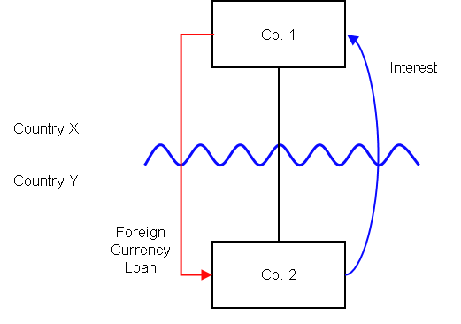

Background
- Co. 1 is resident in Country X.
- Co. 1 owns all the shares in Co. 2, which is resident in Country Y.
- Co. 1’s functional currency for accounting purposes is the official currency in its country of residence, Currency X.
- Co. 2’s functional currency for accounting purposes is the official currency in its country of residence, Currency Y.
- Co. 1 provides Co. 2 with a loan on normal commercial terms (the ‘Loan’). Interest is payable every year in arrears at the market rate and the principal is payable at maturity.
- The loan is treated as a debt instrument under the laws of both Country X and Country Y. The interest payable on the Loan is deductible in Country Y and included in ordinary income under the laws of Country X.
- The interest and principal under the Loan are payable in Currency X.
- The value of Currency X strengthens in relation to Currency Y while the Loan is still outstanding. The accounts of Co. 2 reflect an increase in the principal amount outstanding under the Loan, as expressed in Currency Y, and consequently recognise an exchange loss for the period.
- Under the law of Country Y, Co. 2 is entitled to a deduction for this exchange loss.
- There is no similar adjustment required under Country X law and neither exchange gain nor loss is recognised in profit or loss in Co. 1’s accounts, as its functional currency is the same as that of the Loan - Currency X.

Analysis:
Do the interest payments satisfy the relevant conditions to fall within the scope of the hybrid and other mismatches from financial instruments rules?

Condition A: Are there payments or quasi-payments made under, or in connection with, a financial instrument?
There are payments of interest made in satisfaction of the obligations arising under the Loan. The Loan is defined as a financial instrument for the purposes of UK GAAP, and is therefore within the definition of a financial instrument in s259N.
Condition A is satisfied in respect of the interest payments.
While the deduction for the exchange loss arises from the terms of the Loan, it is not a payment, so we need to consider if it is a quasi-payment. This will depend on whether, making the assumptions at s259BB(4) as necessary, it is reasonable to expect an amount of ordinary income to arise to Co. 1.
Where Country Y is the UK, the exchange loss is not considered to be a quasi-payment – see INTM551030
Whether an exchange gain or loss arises depends on the functional currency of the company. Even if two companies adopt the same approach to accounting, the functional currency of a company is fact-dependent and usually determined by the currency of the primary economic environment in which the entity operates.
The UK allows companies to prepare their accounts in their functional currency and therefore were Co. 1 resident in the UK it would still be permitted to prepare its accounts in Currency X, and no foreign exchange gain would arise.
Where Country X is the UK, it may be reasonable to expect that ordinary income would arise to Co. 1 if it were resident in Country Y and if Country Y required exchange differences to be computed by reference to its official currency, and always took into account exchange differences on loans.
In those circumstances there would be a quasi-payment – see INTM551040.
Condition A may be satisfied in respect of the exchange losses only where the UK is in the position of Country X.

Condition B: Is either Co. 1 or Co. 2 within the charge to corporation tax for a relevant payment period?
The charge to corporation tax is the charge to the corporation tax in the UK.
If the UK is Country X or Country Y, Condition B is satisfied, as either Co. 1 or Co. 2 is within the charge to corporation tax.
If the UK was in the position of both Country X and Country Y then Condition B would also be satisfied. In relation to the deduction for a foreign exchange loss this situation will occur only if one of the companies prepares their accounts in a currency other than UK Sterling. If the UK is neither Country X nor Country Y, then Condition B is not satisfied, as neither Co. 1 nor Co. 2 are within the charge to corporation tax. You will need to consider the remaining conditions only if the imported mismatch rules in Chapter 11 apply.

Condition C: Is it reasonable to assume that there would be a ‘hybrid or otherwise impermissible deduction/ non-inclusion mismatch’ in relation to this payment?
No mismatch arises in respect of the interest payment, so condition C is not satisfied as regards interest.
Although Country X does not require Co. 1 to bring within income a corresponding amount characterised as a ‘foreign exchange movement’ in respect of this movement in the value of the principal, it does require Co. 1 to recognise the amount by virtue of bringing into account the value of the principal in the stronger currency.
If we assume that when the Loan was entered into, it was quantified as X10 (10 in currency X) and Y20 (20 in currency Y), then if during the period the value of currency Y falls such that the equivalent of X10 now becomes Y25 the value of the Loan principal is still X10, independently of which currency you translate it to. In absolute terms there is no mismatch.
Gains and losses that result from converting foreign exchange into local or functional currency are attributable to the way jurisdictions measure the value of money rather than the value of the payment.
The legislation requires there to be a comparison between the relevant deduction and the amount included in ordinary income. In this case whether we quantify the deduction and income in Currency X or Currency Y, than they are equal. There is no requirement to quantify the relevant amounts in a specific currency.
Therefore the foreign exchange movement will not give rise to a ‘hybrid or otherwise impermissible deduction/ non-inclusion mismatch’ provided the proportion of the interest and principal payable under the Loan is the same under the laws of both jurisdiction.
Condition C is not satisfied, and no further analysis is required.

Conclusion
There is no hybrid or otherwise impermissible deduction/non-inclusion mismatch to counteract.
Return to contents

