INTM551320: Hybrids: Financial instruments (Chapter 3): Example: Interest payment to a charity
This example looks at situations where a company which is a registered charity issues a loan to a related company and it is treated as debt in one country and equity in the other. The interest payment is deductible but the interest receipt is not taxed because the charity has exempt status.
The example considers whether the interest receipt is ordinary income within the hybrid and other mismatches from financial instruments rules and how it should be treated.
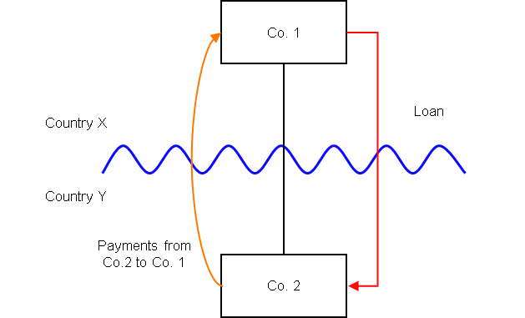

Background
- Co. 2 is a company resident in Country Y.
- Co. 1 is a company resident in Country X, and owns all the shares in Co. 2.
- Co. 1 is a registered charity in Country X.
- Co. 1 lends money to Co. 2 on arm’s length terms (the ‘Loan’), but the terms of the Loan are such that it is subordinated to the ordinary creditors of Co. 2 and can be suspended in the event Co. 2 fails to meet certain solvency requirements.
- Under the laws of both Country X and Y, the Loan is treated as a financial instrument.
- Under the laws of Country Y the payments of interest under the Loan are deductible in calculating Co. 2’s ordinary income for a taxable period.
- Under the laws of Country X Co. 1 is exempt from tax generally by reason of being a registered charity.
- In the absence of that exemption Co. 1 would still not be taxable upon the receipts as the Loan would be treated as an equity instrument (i.e. shares), and as such the payments of interest under the Loan are treated as dividends. Country X usually exempts dividends received from a foreign company where the recipient controls the payer.
- If the Loan had been treated as a debt instrument in Country X then ordinarily a non-charity would be taxable on those receipts.
- The payee is not a relevant investment fund as defined in s259NA.
- The Loan is not a regulatory capital security for the purposes of the Taxation of Regulatory Capital Securities Regulations 2013 (SI 2013/3209).

Analysis - Applying the tests in s259CA TIOPA 2010:
Do the interest payments satisfy the relevant conditions to fall within the scope of the hybrid and other mismatches from financial instruments rules?

Condition A: Are the payments made under, or in connection with, a financial instrument?
There are payments of interest made in satisfaction of the obligations arising under the Loan. The Loan is defined as a financial instrument for the purposes of UK GAAP, and is therefore within the definition of a financial instrument in s259N.
Condition A is satisfied.

Condition B: Is either Co. 1 or Co. 2 within the charge to corporation tax for a relevant payment period?
The charge to corporation tax is the charge to the corporation tax in the UK.
If the UK is Country X, Country Y or both (i.e. a wholly domestic transaction), Condition B is satisfied, as either Co. 1, Co. 2 or both are within the charge to corporation tax.
If the UK is neither Country X nor Country Y, then Condition B is not satisfied, as neither Co. 1 nor Co. 2 are within the charge to corporation tax. You will need to consider the remaining conditions only if the imported mismatch rules in Chapter 11 apply.

Condition C: Is it reasonable to suppose that there would be a ‘hybrid or otherwise impermissible deduction/ non-inclusion mismatch’ in relation to these payments?
The background suggests it is reasonable to suppose that Country Y will permit Co. 2 a deduction (the relevant deduction) for the payment of interest. It is also reasonable to suppose that Country X will not require Co. 1 to bring the corresponding receipt into account as ordinary income for tax purposes.
This creates a potential Case 1 mismatch (as defined in s259CB (2)) as the relevant deduction exceeds the sum of the amounts of ordinary income that, by reason of the payment, arise to each payee in the permitted taxable period.
The mismatch apparently arises because Co. 1 is not within the charge to a tax under the law of any territory because it benefits from an exemption by reason of being a registered charity. Applying the relevant assumption at s259CB(5)(a), we need to test whether the mismatch would still have arisen if Co. 1 did not benefit from such an exemption. If a mismatch would still have arisen, then it is to be treated as arising by reason of the terms, or any other feature, of the Loan.
The background states that if Co. 1 had not benefitted from the registered charity exemption, the receipt would not have been included as ordinary income. The receipt would have been treated as a distribution by reason of a combination of the term of the Loan and the relationship between the parties. A mismatch (in this case, the full amount of the deduction) would still have arisen. The rules recognise that there is hybridity in the financial instrument, and the mismatch is brought within the scope of the hybrid and other mismatches rules.
Condition C is satisfied.
(Note that if Country X treated the Loan as a debt instrument (rather than an equity instrument as outlined above), Co. 1 would include the interest receipt in its ordinary income if the relevant assumption at s259CB(5)(a) was made that Co. 1 did not benefit from the registered charity exemption, and there would not be a mismatch. Accordingly, the mismatch arises only because of the registered charity exemption, and not from the terms or any other feature of the financial instrument. Condition C would not then be satisfied).

Condition D: Are the two companies related or is the Loan, or any arrangement connected with it, a structured arrangement?
Co. 1 owns all the shares in Co. 2, so the companies are related as defined at s259NC.
Condition D is satisfied.
There is no need to consider whether the arrangement is also a structured arrangement.

Conclusion
As all the relevant conditions are satisfied to characterise the arrangement as a ‘hybrid or otherwise impermissible deduction/ non-inclusion mismatch’, the relevant counteractions need to be considered.

Counteraction
The counteraction applied will depend upon whether the UK is in the position of Country X or Country Y (or both).

Counteraction where the UK is in the position of Country Y (the payer jurisdiction)

Primary response
Where the UK is Country Y (the payer jurisdiction), s259CD applies to reduce the allowable deduction by the amount of the ‘hybrid or otherwise impermissible deduction/ non-inclusion mismatch’. In this case, the impermissible deduction/non-inclusion mismatch is equal to the full amount of the deductions.

Counteraction where the UK is in the position of Country X (the payee jurisdiction)

Secondary response
Where the UK is Country X (the payee jurisdiction), it is unlikely that there will be a counteraction. Although the counteraction requires a receipt to be included in ordinary income of the payee, this will not override the relief provided to registered charities where their income is exempted from taxation.
Return to contents

