INTM551300: Hybrids: Financial instruments (Chapter 3): Example: Release of debt obligation
This example looks at situations where the parent company makes a loan to an overseas subsidiary and then releases the company from meeting its obligations under the loan. The parent gets a deduction for the amount of the loan which is forgiven and the release of the debt is not treated as taxable income of the subsidiary.
The example considers whether the release of the debt obligation is within the hybrid and other mismatches from financial instruments rules and how it should be treated.
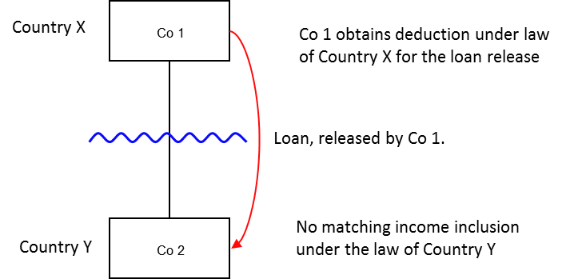

Background
- Co. 1 is resident in Country X.
- Co. 2 is resident in Country Y.
- Co. 2 borrows money from its immediate parent Co. 1 (the ‘Loan’).
- The Loan has a 5 year term and pays a normal rate of interest.
- Co. 2 gets into financial difficulties and is unable to make payments of interest and principal of the Loan.
- Co. 1 agrees to forgive the Loan and releases Co. 2 from the obligation to make further payments of principal and accrued interest. Country X permits Co. 1 a deduction for the reduction in value of this asset.
- Due to the relationship between Co. 1 and Co. 2, Country Y recognises the release as an equity contribution.
- The amount of debt forgiven is treated as deductible under Country X law but is not treated as income under Country Y law.

Analysis – Applying the tests in s259CA TIOPA 2010
Do the payments satisfy the relevant conditions to fall within the scope of the hybrid and other mismatches from financial instruments rules?

Condition A: Is there a payment or quasi-payment made under, or in connection with, a financial instrument?
The release of the Loan is a payment under s259BB(1), as a transfer of money’s worth directly from Co. 1 (the payer) to Co. 2 in relation to which an amount (relevant deduction) may be deducted in calculating Co. 1’s ordinary income for a taxable period.
This release also satisfies the definition of a quasi-payment at s259BB(2) as Co. 1 may claim a deduction and it would be reasonable to expect Co. 2 to bring in a corresponding receipt if it were also resident in Country X and adopted the same approach to accounting as Co. 1. (It would be unusual for a country to allow such a mismatch in domestic transactions).
The payment is made in connection with the Loan, which is within the definition of a financial instrument at s259N.
Condition A is satisfied.

Condition B: Is either Co. 1 or Co. 2, within the charge to corporation tax for a relevant payment period?
The charge to corporation tax is the charge to the corporation tax in the UK.
If the UK is Country X, Country Y or both (i.e. a wholly domestic transaction), Condition B is satisfied, as either Co. 1, Co. 2 or both are within the charge to corporation tax.
If the UK is neither Country X nor Country Y, then Condition B is not satisfied, as neither Co. 1 nor Co. 2 are within the charge to corporation tax. You will need to consider the remaining conditions only if the imported mismatch rules in Chapter 11 apply.
Note: if Co. 1 and Co. 2 were both within the charge to corporation tax it would be unusual for the UK loan relationship legislation to allow such a domestic mismatch. The group mismatch scheme rules in s938A CTA 2010 would also apply.

Condition C: Is it reasonable to suppose that there would be a ‘hybrid or otherwise impermissible deduction/ non-inclusion mismatch’ in relation to this payment?
The background suggests it is reasonable to suppose that Country X will allow Co. 1 a deduction (the relevant deduction) for the release of the Loan. It is also reasonable to suppose that, by reason of the terms or feature of the Loan, Country Y will not require Co. 2 to bring in the corresponding receipt into account as income for tax purposes (ordinary income).
This creates a Case 1 mismatch (as defined in s259CB(2)) as the relevant deduction exceeds the sum of the amounts of ordinary income that, by reason of the payment, arise to each payee in the permitted taxable period, and all or part of that excess arises by reason of the terms or any other feature of the financial instrument. In this case the relationship between Co. 1 and Co. 2 is a feature of the financial instrument that results in Co. 2 recognising the Loan release as an equity contribution.
Condition C is satisfied.
Note: this scenario makes the assumption that the mismatch does not arise by reason of one of the relevant debt relief provision or circumstances defined in s259CC(3). If the excess did arise by reason of a relevant debt relief provision or circumstance, then s259CB(3) would deem the excess not to have arisen by reason of the terms, or any other feature, of the financial instrument and Condition C would not be satisfied.

Condition D: Are the two companies related, or is the Loan or any arrangement connected with it, a structured arrangement?
Co. 1 owns all the shares in Co. 2, so the companies are related as defined at s259NC.
Condition D is satisfied.
There is no need to consider whether the arrangement is also a structured arrangement.

Conclusion
As all the relevant conditions are satisfied to characterise the arrangement as a ‘hybrid or otherwise impermissible deduction/ non-inclusion mismatch’ the relevant counteractions need to be considered.

Counteraction
The counteraction applicable will depend upon whether the UK is in the position of Country X and Country Y (or both).

Counteraction where the UK is in the position of Country X (the payer jurisdiction)

Primary response
Where the UK is Country X (the payer jurisdiction),s259CD applies to reduce the deduction claimed by Co. 1 for release of the Loan by the amount of the ‘hybrid or otherwise impermissible deduction/ non-inclusion mismatch’. On the facts given in this case the entire deduction will be disallowed.

Counteraction where the UK is in the position of Country Y (the payee jurisdiction)

Secondary response
Where the UK is Country Y (the payee jurisdiction) and the deduction has been fully counteracted under s259CD or an equivalent provision, no further action will be taken by the UK.
Where the ‘hybrid or otherwise impermissible deduction/non-inclusion mismatch’ has not been fully counteracted then s259CE applies to counteract the remaining mismatch by including that amount as income arising to Co. 2 for the counteraction period.

Return to contents

