INTM551290: Hybrids: Financial instruments (Chapter 3): Example: Payment to modify a debt instrument
This example looks at situations where the parent company makes a loan to an overseas subsidiary and the subsidiary makes a payment to modify the terms of the loan. The subsidiary gets a deduction for the payment but the receipt is not taxed.
The example considers whether the payment to modify the loan is within the hybrid and other mismatches from financial instruments rules and how it should be treated.
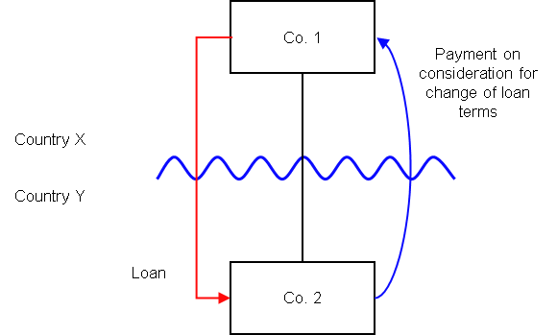

Background
- Co. 1 is resident in Country X
- Co. 2 is resident in Country Y
- Co. 2 borrows money from its immediate parent Co. 1 (the ‘Loan’)
- The Loan has a 5 year term and pays a high fixed rate of interest (but not in excess of an arm’s length rate at the time the loan was advanced)
- Co. 2 makes a one off arm’s length payment to Co. 1 in consideration for Co. 1 agreeing to lower the interest rate on the Loan
- Country Y allows Co. 2 a deduction for this payment (either when made or spread over the remaining life of the loan)
- Co. 1 is not required to bring the receipt in as Ordinary Income as Country X does not subject to tax amounts attributable to a surrender of rights
- The payee is not a relevant investment fund as defined in s259NA.
- The Loan is not a regulatory capital security for the purposes of the Taxation of Regulatory Capital Securities Regulations 2013 (SI 2013/3209).

Analysis - Applying the tests in s259CA TIOPA 2010
Do the interest accruals satisfy the relevant conditions to fall within the scope of the hybrid and other mismatches from financial instruments rules?

Condition A: Are there payments made under, or in connection with, a financial instrument?
The one off payment is a payment as defined at s259BB(1), being a transfer of money in relation to which an amount (relevant deduction) may be deducted in calculating Co. 2’s ordinary income for a taxable period.
The payment is made in connection with the Loan, which is defined as a financial instrument for the purposes of the definitions provided in s259N.
Condition A is satisfied.

Condition B: Is either Co. 1 or Co. 2, within the charge to corporation tax for a relevant payment period?
The charge to corporation tax is the charge to the corporation tax in the UK.
If the UK is Country X, Country Y or both (i.e. a wholly domestic transaction), Condition B is satisfied, as either Co. 1, Co. 2 or both are within the charge to corporation tax.
If the UK is neither Country X nor Country Y, then Condition B is not satisfied, as neither Co. 1 nor Co. 2 are within the charge to corporation tax. You will need to consider the remaining conditions only if the imported mismatch rules in Chapter 11 apply.

Condition C: Is it reasonable to suppose that there would be a ‘hybrid or otherwise impermissible deduction/ non-inclusion mismatch’ in relation to this payment?
The background suggests it is reasonable to suppose that Country Y will allow Co.2 a deduction (the relevant deduction) for the one-off payment against its ordinary income. It is also reasonable to suppose that Country X will not require Co.1 to bring the corresponding receipt into account for tax purposes (as ordinary income).
This creates a potential Case 1 mismatch - as defined in s259CB(2) – as the relevant deduction exceeds the sum of the amounts of ordinary income that, by reason of the payment, arise to each payee in the permitted taxable period, and all or part of that excess arises by reason of the terms of the financial instrument - in this case the Loan.
It is by reason of the adjustment to the terms of the Loan that Country X characterises the payment differently. If either the terms had not been adjusted, or the provisions within the Loan did not allow for such an adjustment, then it would not be characterised as a surrender of rights and the mismatch would not have arisen.
Condition C is satisfied.

Condition D: Are the two companies related, or is the Loan or any arrangement connected with it, a structured arrangement?
Co. 1 owns all the shares in Co. 2, so the companies are related as defined at s259NC.
Condition D is satisfied.
There is no need to consider whether the arrangement is also a structured arrangement.

Conclusion
As all the conditions are satisfied to characterise the arrangement as a ‘hybrid or otherwise impermissible deduction/ non-inclusion mismatch’ the relevant counteractions need to be considered.

Counteractions
The counteraction applicable will depend upon whether the UK is in the position of Country X and Country Y (or both).

Counteraction where the UK is in the position of Country Y (the payer jurisdiction)

Primary response
Where the UK is Country Y (the payer jurisdiction), s259CD applies to restrict the deduction for Co. 2 by the amount of the ‘hybrid or otherwise impermissible deduction/ non-inclusion mismatch’. In this case the entire amount will be disallowed (spread between periods, if appropriate, to reflect its accounting treatment).
Note: If Co. 1 were required to bring some or all of the receipt into account for tax at the end of the Loan term, the counteraction may not be appropriate if the delay is deemed just and reasonable.
If the delay in recognising ordinary income is not just and reasonable, s259CD will apply to deny the deduction, but relief may be available in a later period under s259LA.

Counteraction where the UK is in the position of Country X (the payee jurisdiction)

Secondary response
Where the UK is Country X (the payee jurisdiction) and the mismatch has been fully counteracted by s259CD or an equivalent provision, no further action will be taken by the UK.
Where the ‘hybrid or otherwise impermissible deduction/non-inclusion mismatch’ has not been fully counteracted then s259CE applies to counteract the remaining mismatch by including that amount as income arising to Co. 1 for the counteraction period.
Return to contents

