# INTM550100: Hybrids: Introduction: Hybrid and other mismatch structures within Part 6A

To help in identifying the appropriate part of the hybrid mismatch legislation and guidance, the following diagrams provide illustrative and simplified examples of the main types of hybrid and other mismatch structures to which the rules in each of the main Chapters of the legislation apply.

## Chapter 3 – D/NI mismatch – Financial Instruments

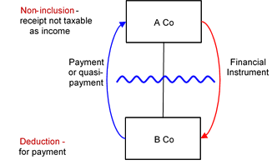

## Chapter 4 – D/NI mismatch – Hybrid Transfers

Hybrid transfers - simple structure

## Chapter 5 – D/NI mismatch - Hybrid Payer

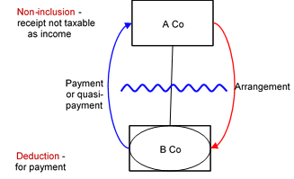

## Chapter 6 – D/NI mismatch – UK PE of Multinational

UK permanent establishment of multinational - simple structure

## Chapter 7 – D/NI mismatch – Hybrid Payee

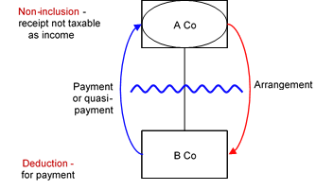

## Chapter 8 – D/NI mismatch – Multinational Payee

Multinational payee - simple structure


## Chapter 9 – DD mismatch – Hybrid Entity

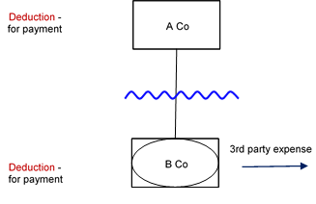

## Chapter 10 – DD mismatch – Dual Territory

Dual territory - simple structure

## Chapter 10 – DD mismatch – Multinational

Multinational - simple structure

[Return to contents](https://www.gov.uk/hmrc-internal-manuals/international-manual/intm550000)