INTM550086E: Hybrids: Introduction: Examples: Interaction with transfer pricing - Imported mismatch

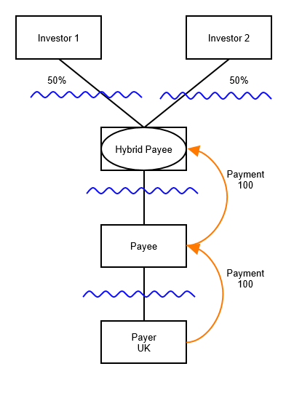

Background 1
- Investor 1 sees Hybrid Payee as transparent.
- Investor 2 sees Hybrid Payee as opaque.
- All relevant jurisdictions see Payee and Payer as opaque.
- Under arm’s length terms, the value of the payment made by Payer would be 50.
Analysis
Determine Relevant Mismatch
The payment of 100 between Payee and Hybrid Payee is the mismatch payment within the meaning of Condition D. It gives rise to a hybrid payee deduction/non-inclusion mismatch (i.e. it would be within the scope of Chapter 7 of Part 6A were Payee resident in the UK).
The relevant deduction in relation to the mismatch payment is 100 (assuming that no transfer pricing adjustment under the law of Payee’s jurisdiction of residency falls to be made). The ordinary income of the payees is 50 (again assuming that local transfer pricing rules do not deem this to be a lesser amount). Accordingly the relevant mismatch is 50.
However, for payments made after 10 June 2021, the amendment in Finance Act 21 at s259KE instructs us to calculate the relevant mismatch as if the mismatch payment had been reduced in the same proportion as the reduction imposed (via the transfer pricing legislation) on the deduction P can claim for the imported mismatch payment (the payment of 100 to payee).
Therefore, given the arm’s length reduction took the deduction available to P from 100 to 50, the mismatch payment should be assumed to be reduced in the same proportion, to 50. In turn this means that the relevant mismatch becomes 25. The relevant mismatch is taken to be the amount it would have been had the arm’s length provision been imposed (i.e. 50) instead of the actual provision (100).
Therefore under Chapter 11, the reduced amount of 50 available as a deduction to P in respect of the payment of 100 is further reduced by the amount of the relevant mismatch, 25.
Applying transfer pricing with Part 6A factored in.
Step 1: Test outcome of actual provision, disregarding transfer pricing rules
Payer makes payment of 100. This is the relevant deduction for Part 6A purposes. Counteraction under Chapter 11 would therefore be to reduce the relevant deduction by the amount of the relevant mismatch, so limiting relief to 50.
Step 2: Test outcome of arm’s length provision
Payer makes payment of 50. This is the relevant deduction for Part 6A purposes. Counteraction under Chapter 11 would therefore be to reduce the relevant deduction by the amount of the relevant mismatch, so limiting relief to 25. The amount of the relevant mismatch is not affected by the substitution of arm’s length pricing at the level of Payer.

Step 3: Test if payer is a potentially advantaged person for transfer pricing purposes
Payer’s tax relief under the actual provision would be 50. Under the arm’s length provision it would be 25. Payer is therefore potentially advantaged.
Step 4: Recompute payer’s tax position as if the arm’s length provision was imposed
Payer is taxed as if it has made a payment of 25.
Corresponding adjustments will not be in point as Payee is not UK tax resident.

Applying Part 6A (Chapter 11) to consider whether a further counteraction is required.
Step 1: Identify relevant deduction
Payer makes payment of 100. However, this exceeds the arm’s length amount so transfer pricing would require recomputation of payer’s tax position as if it was paying 50. Relevant deduction is therefore 50.
Step 2: Apply counteraction
The relevant deduction of 50 is reduced by the relevant mismatch of 25. Accordingly, the counteraction reduces the available deduction to 25. Since this amount is not lower than the amount arrived at via applying Part 4, Part 6A has no further effect.
Return to contents

